Glacial Erosion & Depositional Features
Topic 6

Name ____________________________ Period _____

- What is a glacier and how does it form? __________________________________________________
____________________________________________________________________________________________________________________________________________________________________

- Describe the shape of glacial valley compared to a valley carved by running water. ____________________________________________________________________________________________________________________________________________________________________

- Match the description letter with the following glacial features.

- Landscape feature carved by the glacial ice.
- Landscape feature deposited by the ice (glacial till)
- Landscape feature deposited by the melt-water (outwash)

Letter | Feature |  | Letter | Feature
 | Cirque |  |  | U-Shaped Valley
 | Drumlin |  |  | Horn
 | Esker |  |  | Erratic Boulder
 | Arête |  |  | Hanging Valley
 | Moraine |  |  | Striations in Bedrock
 | Kame |  |  | Kettle Lake

____ 4. Which geologic evidence would best support the inference that a continental ice sheet once
covered a given location?

- polished and smooth pebbles; meandering rivers; V-shaped valleys
- scratched and polished bedrock; unsorted gravel deposits; transported boulders
- sand and silt beaches; giant swamps; marine fossils found on mountaintops
- basaltic bedrock; folded, faulted, and tilted rock structures; lava flows

____ 5. A glacial deposit from ice would most likely consist of

- particles in a wide range of sizes
- particles in the size of pebbles and larger
- sediments in flat, horizontal layers
- sediments found only in the bottoms of stream valleys

____ 6. Which statement presents the best evidence that a boulder-sized rock is an erratic?

- The boulder has a rounded shape.
- The boulder is larger than surrounding rocks.
- The boulder differs in composition from the underlying bedrock.
- The boulder is located near potholes.

____7. The diagram represents a side view of a hill (drumlin) that was deposited by a glacier. This
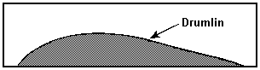
hill is most likely composed of

- cemented sediments
- unsorted sediments
- vertically layered sediments
- horizontally layered sediments

Questions 8-11:
Diagram I shows melting ice lobes of a continental glacier during the Pleistocene Epoch. Diagram II represents the landscape features of the same region at present, after the retreat of the continental ice sheet. Letters A through F indicate surface features in this region.
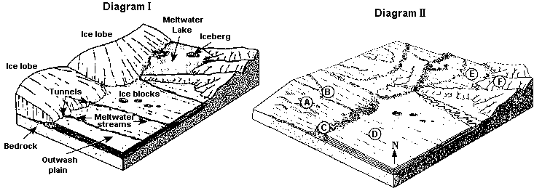

Lower Elevation

____ 8. Which erosional feature most likely formed on the surface of the bedrock under the glacial ice?
- sorted sands
- sand dunes
- parallel grooves
- a V-shaped valley
____ 9. Which features in diagram II are composed of glacial till directly deposited by glacial ice?
- A and C
- B and D
- C and E
- E and F
____ 10. Evidence that several periods of glaciation occurred in the geologic past is provided by
- glacial erratics on the surface
- glacial erosion in the high regions of mountains
- layers of glacial till deposited on top of each other
- discovery of mastodont fossils in the surface bedrock
____ 11. Glacial movement is caused primarily by

- gravity
- erosion
- running water
- global winds

____ 12. The following diagrams depict the formation of which glacial feature?

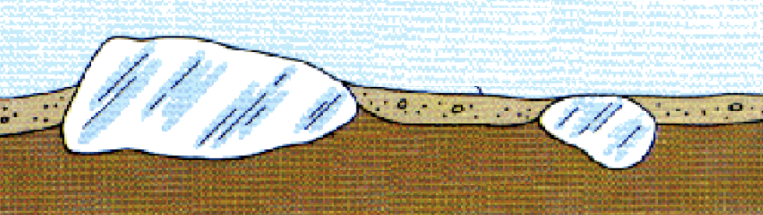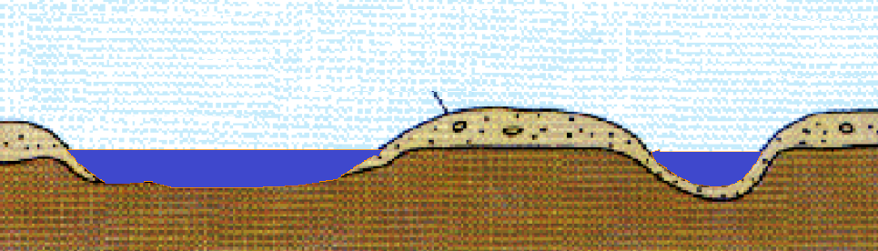
Embedded Ice Blocks in glacial till
Ice melts forming bowl shaped depressions which fill with water

- Finger lakes C. U-Shaped Valleys
- Kettle Lakes D. Eskers

_____ 13. Outwash plains are formed as a result of deposition by

- landslides C. winds from hurricanes
- ocean waves D. meltwater from glaciers

_____ 14. The sediment deposited in the outwash plain of a glacier will be

- rounded and sorted C. angular and sorted
- rounded and unsorted D. angular and unsorted

Map A shows the location of the Finger Lakes Region in New York State. The boxed areas on map A were enlarged to create map B. Map B shows a portion of a drumlin field near Oswego, New York.

15. The arrangement of the drumlins on map B, near Oswego, indicates that a large ice sheet advanced
across New York State. Toward which compass direction did the ice advance in this area?
_________________________

16. Label the following glacial features on the drawing below:
Horn Arete Moraine U-Shaped Valley Hanging Valley Cirque
